
Biotechnology Research Project
BHS000-6
Submitted by
Abdullah Al Mahmud
Student ID: 1863984

Submitted to:
Dr. Prashanth Kumar Bajpe, FHEA
Senior Lecturer in Pharmacological Science
School of Life Sciences
University of Bedfordshire
Word count: 9020(excluding references)

Exploring the function of oncogene ERBB2 by CRISPR CAS technology

Abstract: Cancer is a genetic disease that results from genetic abnormalities affecting normal cellular activities such as division, growth, and death. Different types of tumour suppressor gene and oncogenes are responsible for cancer development. ERBB2, also referred as HER2 (Human Epidermal Growth Factor Receptor 2), is one of the most important ones. HER2 is a receptor tyrosine kinase involved in signalling that regulates cellular growth and survival through pathways such as PI3K/AKT/mTOR and RAS/RAF/MEK/ERK. Dysfunction or mutations of HER2, most frequently linked to overexpression, cause overexpression of this gene, leading to aggressive breast cancer. HER2 is also implicated in ovarian, bladder, gastric cancer, and other cancers.
This study uses CRISPR-Cas9, a precise gene editing tool, to understand the function of HER2 in cancer. CRISPR-Cas9 enables targeted knockout and overexpression of HER2, aiding in understanding HER2’s mechanism of action. The functional assays monitor the effects of HER2 variations on cell growth, survival, and signalling pathways. CRISPR screens are employed to identify genes and pathways related to HER2, helping to find potential targets for therapy. Additionally, creating animal models with specific HER2 mutations enables analysing the effectiveness of novel anticancer treatments in vivo.
This study demonstrates how CRISPR technology can revolutionaries the understanding of the mechanisms that underpin the function of HER2 in cancer. The outcomes may help in the creation of new strategies that can counteract the mechanisms of resistance to current HER2 directed therapies and, consequently, enhance the outcomes for patients suffering from HER2 positive-cancers.
Introduction: The instructions a cell needs to function correctly are found in its genes. Cells get signals from the instructions to multiply, divide, and create new cells. Our bodies develop and recover in this way. Changes can occasionally occur in the cell's genes. A gene that has been altered may no longer provide the right instructions. A gene variant, often known as a mutation, is a change in a gene. Cancer is a genetic disease that caused by the gene mutation. Gene could be muted for various factors, such as, errors in DNA replication, spontaneous chemical changes, radiation, chemical mutagen, environmental pollution, lifestyle, aging etc. According to WHO around 20 million new people was reported cancer and this mostly observed cancer types are lung. ERBB2 also called as HER2 (Human Epidermal Growth Factor Receptor 2), is a gene that codes for a membrane bound receptor tyrosine kinase. The product of HER2 gene is a member of ERBB receptor family which includes EGFR (ERBB1), HER3 (ERBB3) and HER4 (ERBB4). They are involved in regulating cell growth, differentiation, and survival, and are activated through heterodimerization with other members of the ERBB family and their respective receptors. (Yarden & Sliwkowski, 2001).
The ERBB2 receptor also known as HER2 is a receptor tyrosine kinase that is involved in the control of cell growth, differentiation and survival. The structure of the receptor is divided into three regions which include the extracellular domain, the transmembrane domain and the cytoplasmic domain. All these components are vital in the operation of the receptor as well as its function when it binds with a ligand. The ERBB2 receptor has four subdomains in its extra cellular domain (ECD), which include domains I-IV that are involved in receptor association as well as activation. When the ECD of the receptor is in the inactive state the domains II and IV are involved in the folding of the receptor thus preventing for the receptor to dimerize. This closed structure is a mechanism that bars the receptor from adopting an active state where it can signal through downstream effectors. At this stage the receptor is not able to bind with other receptor molecules or start any signalling inside the cell. In most cases, binding of the ligand occurs between domains I and III whereby there is a conformational change that takes place within the ECD, and this results in the liberation of the dimerization arm from domain II. This ‘untethering’ results in the revelation of the dimerization surface thus enabling the receptor to form either homodimer where two ERBB2 receptors are involved or heterodimer where the receptors involve other family members such as EGFR or HER3. The formation of these dimers is important since it leads to the activation of the receptor through allosteric mechanism that affects the intracellular kinase domain. This part of the receptor undergoes tyrosine phosphorylation, and this leads to the activation of certain signalling pathways that are found downstream.
This HER2 interaction is very effective and results in a very effective activation of the Phosphoinositide 3-Kinase/Protein Kinase B (AKT)/Mechanistic Target of Rapamycin (PI3K/AKT/mTOR), Rat Sarcoma/Rapidly Accelerated Fibrosarcoma/Mitogen-Activated Protein Kinase Kinase/Extracellular Signal-Regulated Kinase (RAS/RAF/MEK/ERK) and Janus Kinase/Signal Transducer and Activator of Transcription (JAK/STAT) pathways (Olayioye et al., 2000). The development of cancer is associated with the overexpression or mutations of the hyperactive protein HER2. An altered kinase conformation is maintained when HER2 is overexpressed in tissues, which aids in the development of cancer.
However, it is important because it becomes an oncogene due to dimerization and activation of the gene. This is a receptor because most of its mutant receptors have a part in a variety of malignancies in oncology. When these receptors are mutated, they lead to a significant enhanced involvement in signalling, which in turn causes variations in survival, HER2 invasion, growth, and cell malignancy. Amplification, HER2 gene alterations, and overexpression of the gene cause tissue growth regulatory mechanisms to be disrupted in such cancers. More HER2 receptors are synthesised on the cell surface because of HER2 overexpression, which is often caused by ERBB2 gene amplification.

The oncogenic pathways and tyrosine kinase signalling are overactivated as a result. The PI3K/AKT pathway suppresses pro-apoptotic proteins, which aids in cell survival. The RAS/RAF/MEK/ERK pathway promotes the cell cycle's advancement, which controls cell division. While HER2 controls important proteins involved in angiogenesis and cancer metastasis, the JAK/STAT system also modulates immune signalling pathways and differentiation.

Therefore, HER2 can also stop apoptosis, which is a mechanism that lets tumour cells endure stressors like hypoxia or chemotherapy that are frequently linked to malignancies. Breast cancer accounts for 20–30% of all cases of HER2 amplification, which is the highest occurrence. This is known to happen when ERBB2 is amplified, which results in the development of more HER2 receptors on the cell surface, over-activating signalling pathways, and accelerating the proliferation of cancer cells. This is because the HER2 receptor was discovered during the treatment of breast cancer, and as a result, the system was addressed in later therapies that helped patients. The monoclonal antibody trastuzumab, the first HER2 targeted medication, was created in the late 1990s and has since been used to treat HER2 negative breast cancer. Trastuzumab is an antibody that binds to the HER2 receptor thus preventing it from dimerization and hence does not activate the signalling pathways that cause cell proliferation (Smith et al., 2023). Also, the application of trastuzumab together with chemotherapy was observed to enhance the life expectancy of patients with breast cancer at the initial stage and the advanced stage of the disease (Brown et al., 2023). Nevertheless, the problem of resistance to HER2 targeted therapies has not been solved yet. These include gene mutations HSP90 of chaperone the clients HER2 even gene, with the capacity use of the of cell HSP90 to inhibitors, other signalling pathways coming into play and other receptors being expressed at higher levels (Johnson et al., 2023). This has led to the development of novel HER2 targeted medicines, including as T-DM1, a combination of trastuzumab and a cytotoxic medication that delivers chemotherapy only to the tumour drug which is a method of treating additional tumours has been developed for individuals with low HER2 levels (Smith options et al., in 2023).
HER2 overexpression that occurs in gastric cancer and is detected in 15-20% of cases, which results in enhanced cell division and survival. Trastuzumab is a monoclonal antibody that binds to HER2 receptor and has been chemotherapy used for in the combination treatment with of HER2 positive gastric cancer patients where it has been seen that it enhances progression free survival (Bang et al., 2010). In ovarian cancer, HER2 is a protein which is over expressed in the tumour cells and HER2 is in known ovarian to cancer be is associated a with topic poor of prognosis active and research increased with tumour some aggressiveness. The current study states that HER2 of targeted targeting therapies may have a role in improving the outcome of patients (Zhou et al., 2013). Bladder cancer is another cancer type in which HER2 is over expressed in the advanced stages of the disease and is also seen to be associated with higher tumour grade, increased aggressiveness and a poor prognosis. There is still ongoing research on the HER2 targeted therapy for bladder cancer. However, it presents a possibility to be a novel therapeutic target (Saiki et al., 2013). NSCLC is another cancer which is characterized by HER2 mutations especially in the kinase domain which leads inhibit to HER2 cell and growth is being targeted tested therapies for including the afatinib treatment and of neratinib HER2-mutated have been developed to NSCLC (Sacher et al., 2016).
These mutations do not require amplification, and HER2 ligands into the modifications continuously, implicating HER2 in the wide range of tyrosine kinase inhibitors, afatinib and neratinib. Some cancers, including breast cancer, are particularly aggressive yet respond well to treatments that target HER2, such trastuzumab and pertuzumab. Breast cancer is a kind of cancer that develops in the breast and is defined by the presence of HER2 receptors.
HER2 positivity is seen in about 20% of the patients and is a marker for treatment with trastuzumab. ERBB2 mutations is commonly applied in the therapy of lung cancer particularly NSCLC. As ERBB2 mutations are not common and not very apparent in colorectal and bladder cancers.

CRISPR-Cas systems or Clustered Regularly Interspaced Short Palindromic Repeats and associated proteins are one of the most innovative concepts in the molecular biology field which offers the most accurate tool for genome editing. Originally used as a bacterial defence mechanism against viruses. CRISPR-Cas systems allow the bacteria to recognize and breakdown the virus genetic material. This discovery which was made by Jennifer Doudna and Emmanuelle Charpentier in the year 2012 helped to put into place the foundation of CRISPR which is currently one of the most used tools in genetic engineering (Doudna & Charpentier, 2014; Jinek et al., 2012). CRISPR is currently changing fields such as medicine, agriculture, environment management and even in the advancement of our understanding in science, as well as posing ethical and technical questions that need to be addressed (Zhang et al., 2023; Molecular Cancer, 2023).
The CRISPR-Cas9 system which is the most well-known type works in a way that it has two components: a guide RNA (gRNA) and the Cas9 nuclease. The gRNA serves as a target to a particular DNA, to direct the Cas9 to that spot. After binding of Cas9 to DNA, Cas9 causes a double stranded break (DSB) in the DNA. This break sets off repair processes within the cell including the non-homologous end joining (NHEJ) which often causes mutations or the homology directed repair (HDR) which allows for precise repair with a template (Jinek et al., 2012; Komor et al., 2016). Some examples of such systems are the base editors and the prime editors which come with enhancements that allow for single base edits while not creating DSBs thus minimizing the chances of genetic alterations (Anzalone et al., 2019; Liu et al., 2023). Outside of the DNA editing, CRISPR-Cas systems have been also used for the RNA targeting with the help of Cas13 protein. RNA enables editing the reversible changes in genes without the need to modify the genome which presents a potential for the transient therapeutic interventions. Furthermore, dCas9 has been developed that enables the control of gene expression by bringing in transcription factors or inhibitors, thus expanding the potential applications of CRISPR in the fields of medicine, agriculture, functional genomics, diagnostic, RNA editing, synthetic biology (Zhang et al., 2023; Molecular Cancer 2023).
It has been used to cure genetic diseases which involve modifying genes at their source, for instance, sickle cell anaemia, thalassemia and cystic fibrosis. CRISPR is also being tried on eradicating infections like HIV, hepatitis B by deleting the viral genome in the host cells. CRISPR has also played a great impact in agriculture by means of gene editing in plants and animals, creating crops with improved qualities and disease and drought tolerance. In livestock, CRISPR has been used to develop disease free animals in a bid to address issues of food insecurity and animal welfare. CRISPR is also used in functional genomics to investigate the roles of genes throughout the entire genome; it allows researchers to hyperactivate, hypoactive, or knockout certain genes to understand their part in various biological processes. This technology has been very useful in the identification of genes that are associated with diseases, drug resistance and developmental processes. In cancer research CRISPR screens have identified weaknesses in tumour cells which has led to the development of new therapies. CRISPR diagnostic tools for instance SHERLOCK (Specific High-Sensitivity Enzymatic Reporter Unlocking) and DETECTR (DNA Endonuclease Targeted CRISPR Trans Reporter) have emerged as cost effective and efficient methods for early and accurate identification of diseases. These technologies take advantage of the Cas proteins’ collateral cleavage to identify DNA or RNA targets. CRISPR diagnostics has been complexity very which useful makes in it identifying suitable infectious for diseases point such of as care COVID-19Another area that CRISPR has been is harnessed RNA for editing whereby one is able to make temporary gene expression changes without having to alter the genome. Cas13-based tools have been used in fighting RNA viruses and for post-transcriptional regulation of gene expression.

CRISPR-Cas systems have been applied in the identification of cancer related genes during high throughput functional genomics screens. CRISPR/Cas9 is a type of gene editing tool which enables one to edit genes in the genome which can be knocked out, activated or inhibited to know their functions in cancer and cancer therapy. This technology has greatly helped in determining tumor suppressor genes, oncogenes, drug resistance and susceptibility genes and has made a lot of contribution to cancer studies. CRISPR is among the most frequently applied methods in cancer research, especially the genome-wide CRISPR screens. These screens involve the use of pools of sgRNAs that are targeted to thousands of genes, and the researchers can knock down all the genes and the phenotypic changes that occur in cancer cells. For instance, screens have been carried out to identify genes that are necessary for cancer cell survival; potential therapeutic targets have been identified, for example, genes that are related to DNA repair or immune evasion (Hart T et al. 2015; Shi X et al. 2015). These have identified phenotypes that are characteristic of specific cancers, including the synthetic lethal interactions through which the targeting of a gene will lead to cell death only if the cell has a particular mutation. Besides loss of function experiments CRISPR/Cas systems have been used for gain of function and epigenetic regulation through CRISPR activation (CRISPRa) and CRISPR interference (CRISPRi). These approaches enable researchers to investigate overexpression and knock down of genes, which leads to the determination of genes that when dysregulated cause tumour formation or metastasis. For example, CRISPRa has been applied to identify transcription factors and signalling proteins that drive oncogenic processes. Another innovative way of applying CRISPR is in the identification of genes that cause drug resistance and sensitivity. Such screens have been carried out in the presence of chemotherapeutic resistance. drugs For or instance, targeted CRISPR therapies screens to have identify demonstrated resistance that mechanisms loss and of new genes ways that of mediate using apoptosis the including therapies to counteract TP53 can render cells resistant to DNA damaging agents; thus, highlighting the targets for the re-sensitization of the therapy (Wang et al., 2017). CRISPR is also effective in the analysis of cancer variation and other aspects of the microenvironment. With the help of CRISPR, it becomes possible to model multifaceted crosstalk between cancer cells and their microenvironment and assess the effects of certain genes on immune evasion or angiogenesis, for instance (Manguso et al., 2017). In addition, in vivo CRISPR screens with patient-derived xenografts or genetically engineered mouse models help to model the gene function and therapeutic vulnerabilities in more physiological settings.
The reason for the application of CRISPR technology in assessing the function of ERBB2 gene (also referred to as HER2) is because CRISPR provides the flexibility of making genetic alterations with an unprecedented precision thus enabling the identification of the gene’s function and its association with diseases including cancer. ERBB2 gene is a receptor tyrosine kinase gene that is involved in the regulation of cell growth, cell survival and differentiation. ERBB2 gene products or the gene itself undergoes alterations such as overexpression or mutations which are known to cause several cancers including breast cancer which is characterised by aggressive tumour growth and fatal outcome. It is therefore important to know the role of ERBB2 gene to enhance the development of new cancer treatment strategies and novel molecular targeted therapies including trastuzumab that inhibits HER2 function. The utilization of CRISPR as the technique for investigating ERBB2 is because of the precision that it offers in genetic alterations. CRISPR-Cas9 is one of the most efficient tools for the targeted editing of the ERBB2 gene, that allows researchers to understand the effect of certain mutations or deletions of the gene. For instance, scientists can develop knockout models to show the effects of loss of ERBB2 and see how this affects cellular activities such as proliferation, differentiation and apoptosis. With the use of mutant models, CRISPR can mimic the dysregulation of ERBB2 expression observed in cancer making it a useful tool in the study of cancer. This is an improvement on previous techniques like RNA interference or viral vectors since they pose off target effects. mutations into the Another ERBB2 benefit gene of which CRISPR are often that observed it in can cancer introduce patients. Cancer related These mutations result in the constitutive activation of the ERBB2 protein which is a known oncogene. Thus, through introduction of these specific mutations using CRISPR, it is possible to elucidate the mechanisms by which these genetic defects promote cancer, for instance through the activation of PI3K/AKT and MAPK pathways that are vital for cell growth and division. Furthermore, the CRISPR/Cas9-based functional screens enable the identification of other genes and pathways which are related to ERBB2, which may lead to the identification of new potential therapeutic targets. Yet another benefit of CRISPR in the analysis of ERBB2 is the capability to perform high-content genetic screening. These screens can evaluate the effects of alterations in ERBB2 gene on many genes and signalling pathways at once, thus offering a systems-level perspective of the roles of ERBB2 in cellular networks. This is particularly useful when it comes to cancer since cancers are characterized by the dysregulation of many genes and signalling pathways which results in cellular uncontrolled growth. Through the systematic analysis of the effects of ERBB2 modulations, CRISPR technology can give new perspectives on the network of interactions that involve this gene and other oncogenes or tumour suppressor genes and can thus lead to the identification of new therapeutic targets CRISPR or that biomarkers lead to precise. Finally, alterations the in generation the of animal ERBB2-related genome cancer is models very using useful for the development of the findings made in the laboratory and their application in clinical practice. Through the generation of models that carry certain ERBB2 mutations or overexpress the gene of interest in the animal system, one can analyse tumour development, the effects of potential therapeutics, and the part taken by ERBB2 in cancer spread and treatment response. This also enables the analysis of the effects of combination therapies which include ERBB2, and other molecular targets involved in cancer.
Aims: The purpose of this project is to understand the role of ERBB2 (HER2) in cancer with the generation of ERBB2 knockout and overexpression models using CRISPR-Cas9. Through the examination well of as the effects major of signalling ERBB2 pathways modulation including on PI3K/AKT, cell MAPK growth, and death and differentiation as JAK/STAT, this study aims at understanding the role of ERBB2 in tumour progression and therapy resistance so as to advance the field of precision oncology and tailored therapeutic approaches.
Materials & Methods:
In the lab, the first activity was to set up the reaction mix for oligo phosphorylation and annealing. Using a very small tip measured 1 µL of oligo 1(ERBB2 F1) and then 1 µL of oligo 2(ERBB2 R1) in an eppendorf. To make sure that the environment was right for the reaction, including 1 µL of 10X T4 Ligase Buffer which is very essential for the reaction and then 6. 5 µL of distilled water(ddH2O). Then added the last component of 0. 5 µL of T4 PNK into the mixture and made 10 µL reaction all together. In this case, to ensure the two oligos were phosphorylated and ready to be hybridized, the mixture was placed in a thermocycler set to 37°C for 30 minutes. Thereafter, the temperature then heated stepped at down 95°C facilitate for o 5 minutes oligos to stop hybridize. The temperature was brought down to 25 °C from the initial 37 °C at a constant gradient of 5 °C per minute. At this point the oligos were now prepared for the subsequent process in the experiment.
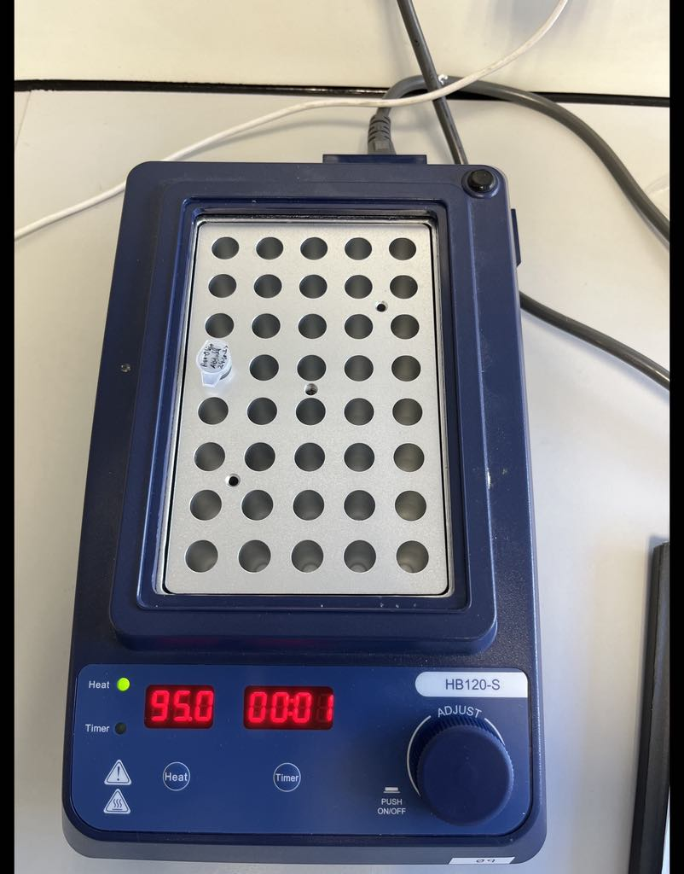
Figure1: Oligoes in thermocycle.
In the lab, things were rather quiet while the experiment was being conducted. The goal was to clone a guide sequence into the sgRNA scaffold of PX330-based plasmids, including PX458-462 which had SpCas9 or the SpCas9n D10A nickase. The whole process began with the synthesis of two oligos that were to form the guide RNA as described below.

The first oligo was 5’ – CACCGNNNNNNNNNNNNNNNNNNN – 3’
The second oligo was 3’ – CNNNNNNNNNNNNNNNNNNNCAAA – 5’
These sequences were synthesized in a way that would enable them to be cloned into the PX459 backbone as indicated above.

To start the reaction mixture cloning, the reaction mixture for cloning was prepared by combining plasmid DNA with FastDigest BbsI enzyme to digest the plasmid at the desired restriction site. To prevent unwanted ligation, FastAP was added to remove any 5' phosphate groups. A suitable buffer was included to provide the optimal environment for enzyme activity, and distilled water was added to adjust the reaction to the desired final volume.
The reaction was carried out at 37°C for 30 minutes so that the enzymes could digest the plasmid. The plasmid was ready for the next process after digestion and this included annealing of oligos and cloning of the guide sequence into the plasmid to be used in the experiment. This step would bring the project a little closer to the achievement of gene editing. The plasmid DNA was digested with specific restriction enzymes, and the resulting fragments were analysed through agarose gel electrophoresis. The gel was stained with an appropriate DNA stain, and the bands were visualized under UV light to confirm the correct size and presence of the expected sgRNA insert.
The DNA purification process began with preparing the DNA Wash Buffer by adding ethanol to the buffer according to the manufacturer's instructions. The buffer bottles were kept tightly closed except during use. A DNA fragment was carefully excised from an agarose gel using a clean, sharp tool, ensuring minimal UV exposure and removal of excess agarose. The gel slice was transferred to a microcentrifuge tube, and its weight was determined. Gel Dissolving Buffer was added in proportion to the weight of the gel slice to ensure optimal conditions for DNA recovery. The sample was incubated in a water bath at an appropriate temperature and occasionally mixed until the gel was fully dissolved. The dissolved sample was applied to a spin column placed in a collection tube, and centrifugation was performed to capture the DNA on the column. The column was washed twice using the DNA Wash Buffer to remove impurities, and centrifugation or vacuum processing ensured complete removal of contaminants. For elution, the column was transferred to a clean tube, and Elution Buffer was added to the centre of the column. After a brief incubation, the column was centrifuged to collect the purified DNA. For larger DNA fragments, using pre-warmed Elution Buffer improved recovery. The purified DNA was then ready for downstream experiments.
Two ligation reactions were made one with oligos and the other one without oligos. For the reaction with oligos, it included BbsI digested plasmid, phosphorylated and annealed oligo duplex, ligation buffer and water to give the necessary reaction conditions. In the control reaction, the same components were used, only the oligo duplex was not added, and the amount of water was increased to replace the volume of the oligo duplex. Quick Ligase was then introduced into both reactions and the mixtures were left to stand at room temperature for 10 minutes to complete the ligation process.
For the transformation, NEB 5-alpha Competent E. coli cells were kept on ice to allow adequate time for DNA uptake. This ensured that the cells reached the proper state for transformation. When the cells were ready, plasmid DNA was introduced into the mixture, which was gently tossed to mix thoroughly without creating any shear force. The mixture was then left on ice, ensuring that the DNA remained stable while in contact with the cells. The cells were subsequently subjected to a specific heat shock at a high temperature for a short duration to promote DNA uptake. Following the heat shock, the mixture was returned to ice to stabilize the cells and prevent further thermal effects. A nutrient-rich medium at room temperature was then added to the tube to facilitate cell recovery and expression of the newly incorporated genetic material. The tube was incubated at an elevated temperature with vigorous agitation to ensure proper aeration and optimal recovery of the transformed cells.

Meanwhile, selection plates were warmed to the required temperature. Four different reaction tubes were prepared for plating:
- Negative control: No plasmid DNA added, to check for any background contamination.
- Positive control: A known plasmid DNA (positive control plasmid) to ensure the transformation system is working.
- Self-ligated sample: 5 µL of the sample from the ligation reaction, to check for successful ligation.
- PX459 oligos sample: 5 µL of the sample from the PX459 oligos reaction, to check the results of the specific ligation.
After the recovery period, the cell suspensions were gently mixed, and a small volume from each tube was pipetted onto the surface of prepared LB agar plates containing ampicillin. A sterile spreader was used to evenly distribute the cells across the plate. The plates were then incubated overnight at 37°C to allow bacterial growth and colony formation.

Post transformation verification: After the transformation was over, the plates were assessed for the appearance of bacterial colonies. Proper transformation was evidenced by the formation of colonies on the experimental plates while the control plate containing no plasmid DNA was expected to have no colonies. From the experimental plates, individual colonies were carefully chosen with the help of a sterile tool. Every colony was cultured in a fresh tube filled with a small amount of LB medium to allow the growth of the bacteria. The tubes were put in a shaker at 37 °C for overnight to enable the bacteria to grow to high density in the liquid medium.
After the completion of the transformation and the measurement of the plasmid concentration, the oligo sequence was derived. To design the mutations, the wild-type ERBB2 sequence was obtained from the Ensemble database as the control. The next step was to use this sequence as a base for generating mutations at certain targeted locations along the ERBB2 gene. First, three nucleotides were successively knocked out one by one, with each deletion being analysed to monitor its impact on the gene by using Benchling. These deletions were targeted to affect the ERBB2 sequence and assess the impact of the loss of nucleotides on gene activity. All these changes were made using the CRISPR/Cas9 system with the help of sgRNA.
Next, three different nucleotides were inserted at the same target locations. These insertions were made at the same position at the upstream of PAM sequence. This approach, enabled by the Benching platform, facilitated the introduction of the mutations. Finally, six distinct mutations were accurately created, which included both DNA deletions and sequence insertions at certain parts of the ERBB2 gene. These mutations were predicted to offer essential information regarding the role of ERBB2 in cancer.

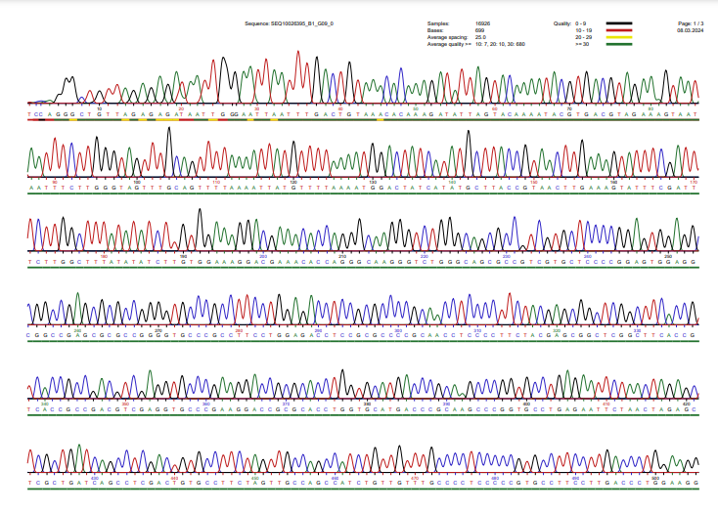
Figure 2: sequencing of pX459-Control (ERBB2 Wild type)

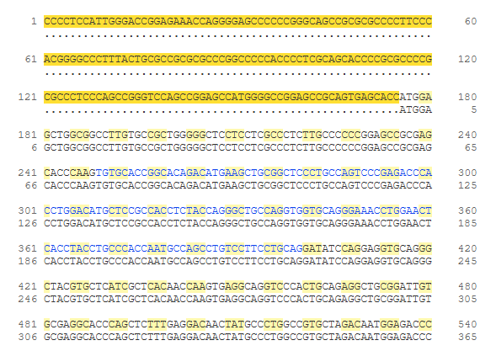
Figure3: ERBB2 genomic sequence from ensemble
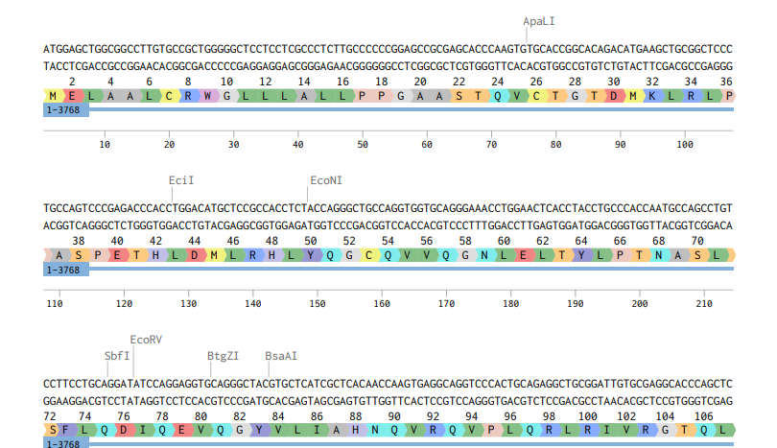
Figure 4: ERBB2 wild type genomic sequence form Benchling
Result: The purpose of this study was to create mutations on the ERBB2 gene which is associated with cancer using the CRISPR/Cas9 gene editing tool. The following stages were part of the experimental procedure: The first of them is to design the guide RNAs, then clone them into the PX459 plasmids, then transform the competent E. coli cells, and finally, to use CRISPR to cause mutations. The outcome of each of the key stages is presented in detail below together with an analysis of how the objectives of the experiments were met
The first major step in our experiment was the preparation of two oligonucleotides (oligos), ERBB2 F1 and ERBB2 R1 which were to be subsequently used to create the guide RNA (sgRNA). The phosphorylation of the oligos was necessary for their subsequent ligation and for their being incorporated plasmid into the oligo sequences were designed in a way that they would bind to a part of the ERBB2 gene which is associated with cancer (Shao et al., 2019). To guarantee the effective phosphorylation T4 PNK was employed. This kinase was able to phosphorylate the 5’ end of the oligos which allowed them to be ligated into the plasmid backbone (Almeida et al., 2020). The reaction conditions were thus maintained in a way that would help the phosphorylation reaction to reach completion to inactivate the reaction, the mixture was heated to 95 °C for five minutes after being maintained at 37 °C for thirty minutes. After that, the temperature was gradually adjusted to allow the oligos to anneal, forming a double-stranded structure. Proper phosphorylation and annealing of the oligos was very important for the sgRNA to be able to interact with Cas9 protein for genome editing as described (Mali et al., 2013). The sequence was
CACCGCCGGCACAGACATGAAGCTG
aaacCAGCTTCATGTCTGTGCCGGC

The next process after annealing and phosphorylation of the oligos was to clone the sgRNA into the PX459 vector. The PX459 vector which is a CRISPR/Cas9 vector was selected because it can provide the capability to express both the Cas9 endonuclease and the sgRNA in the mammalian cells (Sanjana et al., 2014). The first process in cloning was the digestion of the PX459 vector with the restriction enzyme BbsI which cut the plasmid at the specific regions which flanked the sgRNA insertion region. Then used FastAP, a phosphatase enzyme to strip the 5’ phosphate from the plasmid to ensure that the vector does not self-ligated (Zhang et al., 2021). This meant that only the joining of the sgRNA sequence to the vector would take place. The next process was to isolate the plasmid over. After the phosphorylated preparation and of annealed the oligos plasmid was then inserted into the PX459 vector that was digested with BbsI. For this, used Quick Ligase, which is an enzyme that helps in the ligation of the insert into the plasmid. The ligation reaction was set at room temperature for 10 minutes and the ligation products were then checked through gel electrophoresis to confirm the ligation. The ligation reaction therefore generated the recombinant plasmids which has the sgRNA that is specific for ERBB2 gene. As a result, the ligation reaction produced recombinant plasmids containing the sgRNA specific to the ERBB2 gene, a critical step in preparing the system for downstream CRISPR/Cas9-mediated gene editing (Li et al., 2020).
The DNA purification and the gel electrophoresis experiments proved that DNA was isolated and purified efficiently from the tissue samples and the integrity of the DNA was maintained. The DNA fragment was easily taken out from the agarose gel with least exposure to UV radiation and the gel slice was dissolved using gel dissolving buffer in ratio to its weight to ensure that all the gel was used. The dissolved DNA was then transferred to the matrix, a silica membrane embedded in a spin column, with the help of chaotropic salts in the buffer, which helped in the selective adsorption of DNA. Other components including agarose, proteins and salts were washed away by giving two washes with DNA Wash Buffer and centrifugation to ensure that all the contaminants were removed. Elution Buffer was then introduced into the centre of the spin column to collect the purified DNA, with the use of pre-warmed buffer enhancing the recovery of the longer DNA strands. The DNA was without any contaminants and could be used for other applications including PCR or cloning. The correctness of the experiment was also confirmed through the gel electrophoresis and the experiment was successful as distinct and bright bands were observed in the experimental lanes. In the absence of smearing, the bands were well resolved with the DNA ladder, which showed that the fragments had the expected sizes; differences in the band intensities represented the variations in DNA concentration. The clear gel and well-defined band patterns showed that the purification was effective, and the DNA was in a good condition for use in sensitive experimental assays.

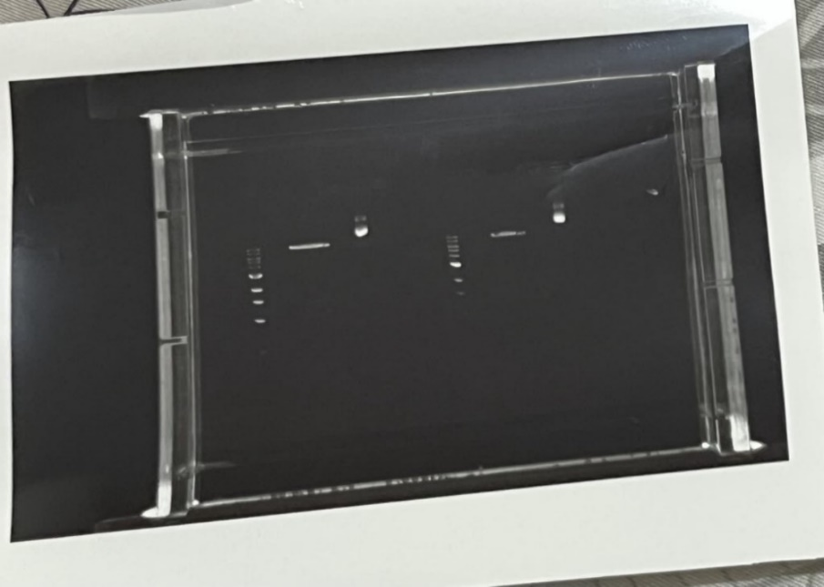
Figure 5: Gel electrophoresis
Here the heat shock transformation method was used to introduce recombinant PX459 plasmids into E. coli NEB 5-alpha chemically competent cells as shown in the picture below. The strategy involved keeping the cells on ice to ensure that their membranes are intact; then subjecting to the heat cells to make the membranes permeable and then allow the growth of the cells in a rich nutrient media. The PX459 recombinant plasmid has an ampicillin resistance gene which will allow the authors to select for transformed cells on LB agar plates containing ampicillin.
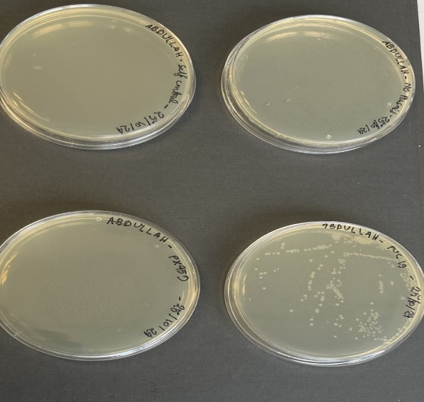
Figure 6: Transformation of cells
The image presents four plates: In the first plate which is the negative control plate, this is shown in the top left corner of the figure; in the second plate which is the positive control plate this is shown in the bottom right corner; in the third plate which is the self-ligation sample plate this is shown in the bottom left corner; and in the last plate which is the oligo-insert sample plate this is shown in the top right corner. The absence of colonies on the negative control plate indicates that there was no presence of bacterial growth, or the resistance was not transferred from previous cultures hence the results are reliable On the other hand, colonies were observed on the positive control plate, the self-ligation plate and the oligo-insert plate suggesting that the plasmid was internalized into the bacterial cells whether with or without the oligo insert. These results show that the transformation protocol is both efficient and specific. The experimental plates evidence the presence of E. coli bacteria with the recombinant PX459 plasmid that will be used in gene editing experiments in the future. This is a successful transformation which shows how efficiently NEB 5-alpha cells can take up DNA and their ability to select for growth in the presence of antibiotics here ampicillin was used to select for cells that contain the plasmid.
The experiment's next main objective was to use the CRISPR/Cas9 system to create mutations in the ERBB2 gene after the successful transformation was confirmed. To do this, created guide RNAs (gRNAs) that target certain ERBB2 gene areas that are known to contribute to the development of cancer. The CRISPR/Cas9 system was used to create mutations by creating sgRNAs that induced certain deletions and insertions at target regions. The wild-type ERBB2 sequence was taken from the Ensemble database. Initially, we used a sequence of deletions to target the gene, removing three nucleotides at various locations. Every deletion was thoroughly examined to determine how it affected the gene's ability to function. These deletions were expected to create frameshifts or disrupt key protein domains involved in the oncogenic activity of ERBB2. In the first mutation, the changes start from 32 amino acid position of the protein and the first stop codon was in 91 positions.
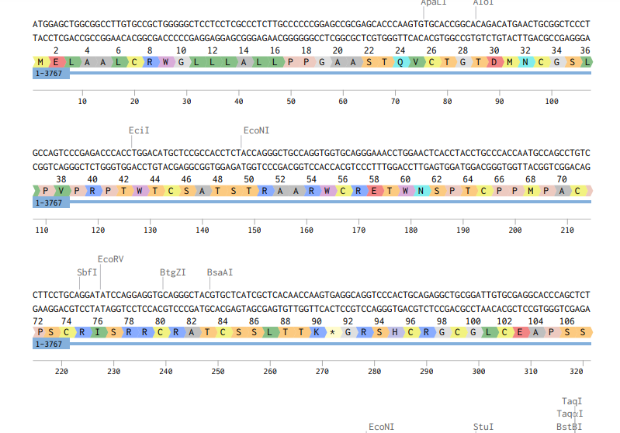
Figure 7: Mutation 1 (deletion of a Guanine)
In the 2nd mutation after deletion of Adenine and Guanine the first stop codon found at 108 positions and after that 199,209,232,236 and other positions of amino acid.
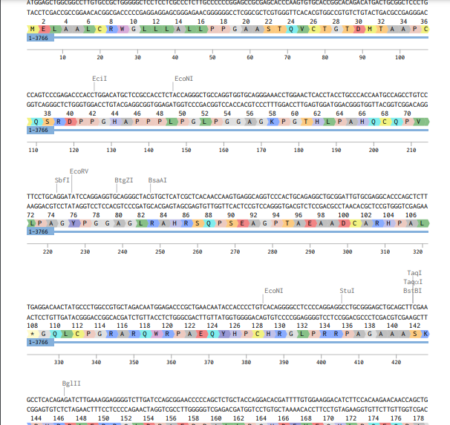
Figure 8: Mutation 2
In the 3rd mutation, the stop codon found on 1255 position of amino acids after the deletion of AAG from 94 to 96 nucleotide.
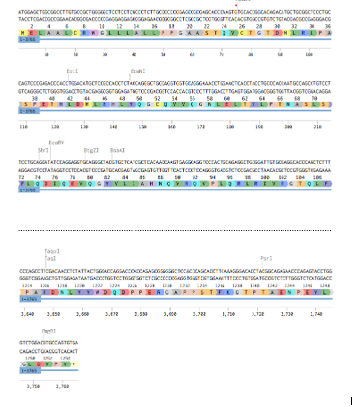
Figure 9: Mutation 3

In the 4th mutation the insertion of Thymine (T) at 94 positions of nucleotide generated the stop codon on 108, 198, 209, 233,237,250, 264 at other positions of amino acids.

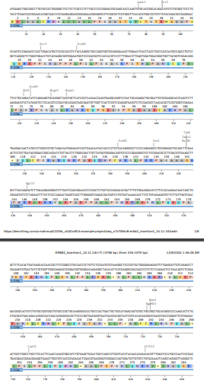
Figure 10: Mutation 4
In the 5th mutation the insertion of Adenine (A), generated stop codon on 91, 117, 123, 149, 154, 183,184 and other positions.
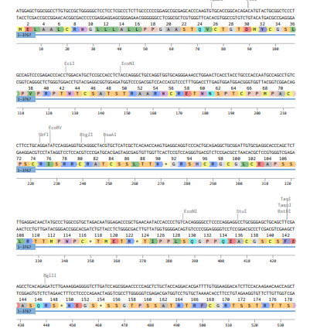
Figure 11: Mutation 5
In the 6th mutation the insertion of thymine, adenine and cytosine in position 94 to 96 generated stop codon on 1256 position of amino acids.
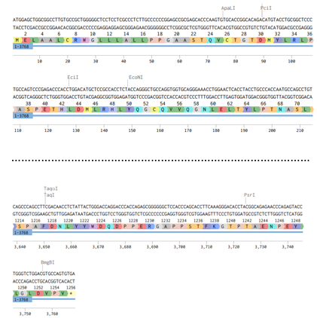
Figure 12: Mutation 6
Discussion: The ERBB2 mutation results in a frameshift at position 32 with a premature stop codon at position 91 which completely distorts the HER2 receptor structure and function. Frameshift mutations take place when there is an addition or deletion of nucleotides which causes the shift in the reading frame of the gene sequence; this results in changes in the amino acid sequence from that point and may result in the formation of a shorter protein. In this case, the frameshift deletes lysine at position 32, a residue that is important in the formation of L domain of HER2 for receptor clustering with HER3. Lysine deletion affects dimerization and signalling for oncogenesis; on the other hand, the deletion at position 91 gets rid of essential domains of the receptor that is required for function such as the transmembrane and tyrosine kinase domains. This mutation can thus inhibit the HER2-dependent cell growth and as such may slow down tumour growth, but it makes the treatment harder as it affects the standard therapies. However, this mutation helps to prevent HER2-dependent cell growth, which makes it difficult to treat with standard therapies such as trastuzumab and leads to the activation of other pathways. All these issues are addressed by using advanced diagnostics, new therapeutic approaches and comprehension of the mechanisms that govern HER2 structure and function in cancer.
This lysine residue at position 32 within L the domain of HER2 is essential for the stability of the receptor and its ability to form heteromers with the other members of the erbB family as is the case of HER3. This step is important as it leads to the formation of dimers which in turn activates signalling pathways like PI3K/AKT and MAPK that are involved in cell growth, survival and tumour development (Yarden and Sliwkowski, 2001). Due to its positive charge, lysine interacts with other charged residues in the L receptor domain and of thus the helps to stabilize the receptor structure. When lysine is mutated, it hinders the formation of these interactions thereby affecting the stability of the domain and hence the receptors’ capacity to form functional dimers. HER2 can no longer function as a co-receptor for ligand-independent signalling in the absence of functional dimerization. Oncogenic signals, which are essential in HER2-driven malignancies like HER2-positive breast cancer, are prevented from being amplified by this disruption. An early event in the frameshift mutation is the loss of lysine at position 32, which sets off a series of structural alterations that eventually result in a shortened, nonfunctional receptor.
The frameshift mutation leads to creation of a stop codon at 91st amino acid which results in transmembrane the domain deletion that of is most used of in the localizing receptor’s HER2 functional to regions. The cell truncation surface involves the as removal of the intracellular tyrosine kinase domain that is involved in phosphorylating substrates with a view of activating downstream pathways. This makes the receptor unable to function as a tyrosine kinase and therefore inhibits its function in initiating oncogenic signalling. The receptor's capacity to interact with targeted treatments, such as trastuzumab (Herceptin), is similarly impacted by this truncation. Trastuzumab inhibits dimerization and signalling by binding to the extracellular domain of HER2. In tumours with this mutation, trastuzumab is useless because the truncation removes this binding site. Treatment plans are complicated by the inability to employ conventional HER2-targeted medicines, which calls for alternate methods.
Loss of HER2 function can also have negative impacts even when the tumours are dependent on HER2 signalling. When the function of HER2 is lost, it can lead to the activation of pathways other such signalling as EGFR or MET to maintain cell survival and proliferation. These backup pathways can cause the therapy resistance and may result in even more aggressive disease phenotypes. For example, EGFR signalling can continue the cell growth after the inhibition of HER2 function which shows the plasticity of tumours (American Cancer Society, 2023).

Furthermore, the carboxyl terminal part of the protein may act in a dominant negative manner, thus inactivating other members of the HER family. Through the formation of nonfunctional heterodimers, the mutated receptor can affect the function of HER3 or HER4 receptors thus affecting the normal cell processes and hence the behaviour of the tumours (Journal of haematology & Oncology, 2023). This makes the cancer biology and the treatment response even more complex and therefore needs more insight into these interactions for management. For personalised cancer treatment, this mutation must be found. Such truncations could be difficult to find using conventional diagnostic techniques like fluorescence in situ hybridisation (FISH) and immunohistochemistry (IHC). To find frameshift mutations and adjust treatment plans appropriately, advanced genomic tools like next-generation sequencing (NGS) are crucial (My Cancer Genome, 2023). Treatments that target downstream signalling pathways, such PI3K or MEK inhibitors, or combination treatments that address compensatory mechanisms, like EGFR or MET inhibitors, may be beneficial for tumours with this mutation. Furthermore, there are also novel therapeutic approaches that could be explored in the management of breast cancer. In this regard, the use of drugs that can block the function of the truncated receptor or target its weaknesses can be tried. It will be important to determine the effects of this mutation at the structural and functional levels to create such interventions. The outcomes of such studies conducted in preclinical studies and clinical trials regarding these strategies may help in identifying how to deal with the problems raised by this mutation (Yarden & Sliwkowski, 2001; Guillette et al., 2018).
In the 2nd mutation, deletion of 2 nucleotide generated stop codon on 108 position of amino acids, & 4th mutation the insertion of one nucleotide showed the same result as 2nd mutation. The 5th mutation the stop codon found on 91 amino acids position which is same as the 1st mutation. All these mutations changed the 32 positions of amino acid from Lysin (K) to Threonine (T) in 2nd mutation, Serine (S) in 4th mutation, Tyrosine (Y) in 5th mutant of ERBB2.
All these mutations result in the consistent truncation of the L domain of the receptor and thus affect the receptor’s ability to dimerize and signal through pathways such as PI3K/AKT and MAPK. Thus, the loss of these essential functions leads to the disruption of normal cellular growth and division. Instead, the truncated proteins might have dominant negative effects or cause constitutive activation of the receptor which is also oncogenic. All these structural mutations share a common pathological mechanism irrespective of the type of mutation whether it is deletion or insertion of single or double nucleotides: disruption of HER2 signalling.
All these mutations delete the HER2 receptor before the intracellular tyrosine kinase domain which renders the receptor unable to signal for cell growth. However, they can still contribute to the formation of the tumour and or compensate for other forms of signalling. This also affects the therapies like trastuzumab which works on this domain as the extracellular domain is also deleted. This highlights the fact that there therapeutic is modalities a like need PROTACs for or new customized approaches immunotherapies such for as the TKIs truncated that receptor block variants. the downstream effectors or the latest.
In Mutation 3, three base pair deletion affects the ERBB2 gene. This deletion affects the protein coding sequence which starts at the 32nd amino acid where lysine (K) is replaced by leucine (L). After this change the amino acid sequence is completely different from the wild type of sequence and is thereafter to the amino acid position 1254. A stop codon is created at position 1255 which results in early termination of the protein.

This frameshift mutation leads to creation of non-functional or incorrectly folded HER2 protein. The missing domains in the shortened protein may cause the improper homodimerization and activation, which results in the activation of signalling pathways such as PI3K/AKT and MAPK. These pathways play an essential role in cell growth, adhesion, and angiogenesis, which are upregulated in cancers including breast and gastric carcinomas. The stop codon also inhibits the synthesis of domains of the protein that are crucial for ligand binding and kinase activity management, which in turn affects the normal cellular regulation.
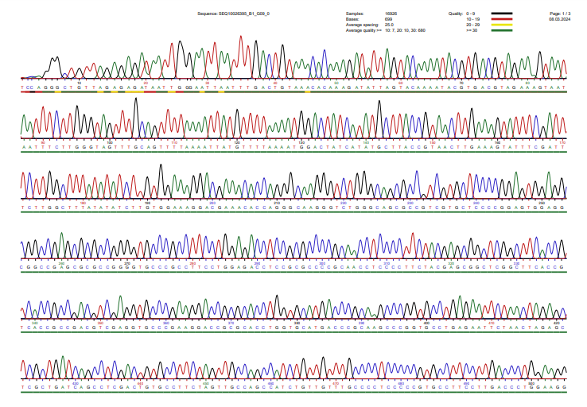
Figure 13: sequencing of pX459-ERBB2 mutated

In Mutation 6 a single nucleotide is inserted in the ERBB2 gene. This mutation causes a shift in the reading frame also starting at the same 32nd amino acid but instead of lysine (K) a tyrosine amino (Y) acid is sequence introduced. up This 1256 affects position the 1255 of which is a stop codon, one amino acid more than the wild type of protein.
While compared to Mutation 3, this frameshift generates a longer protein chain which may generate new, possibly damaging, properties. The new amino acid sequence may generate new and aberrant structural features or generate new gain of function effects that enhance the oncogenic potential of HER2. For instance, these changes may lead to increased kinase activity or enhanced resistance to proteasomal degradation thus allowing signalling to be sustained in the cancer related pathways.
Normally, HER2 is a receptor tyrosine kinase which is part of the EGFR family and is involved in cell growth and differentiation. Alterations in HER2 structure due to frameshift mutations can lead to: Alterations in HER2 structure due to frameshift mutations can lead to
- Constitutive Activation: Sometimes due to aberrant HER2 proteins they may form ligand-independent dimers which results in the constant activation of downstream signalling cascades.
- Evasion of Apoptosis: The sustained activation of PI3K/AKT pathways prevents programmed cell death, providing a survival advantage to tumour cells.
- Increased tumour aggressiveness. Over activity of HER2 is linked with increased invasive and metastatic potentiality especially in the breast and gastric cancers.
Frameshift mutations are very deleterious as they result in the creation of proteins which are different from the proteins which are normally found in the body. Changes in the deletion of crucial regulatory domains and addition of new domains result in the formation of proteins that are either super active or inactive leading to disruption of balance of the cell.
HER2 mutations, including those with frameshifts, are now known to be oncogenic drivers. In cancer biology the ERBB2 gene is classified as an oncogene because its overexpression or mutation results in formation of tumours and tumour growth. Some research has also demonstrated that ERBB2 frameshift mutations are frequent and are associated with increased tumorigenic potential and adverse prognosis.
These mutations are oncogenic because of their
• Bypass Growth Control Mechanisms: The mutated HER2 proteins can signal independently of the extracellular environment and therefore stimulate cell division without regulation.
• Promote Genetic Instability: Altered HER2 signalling has been also found to cause DNA damage and chromosomal instability which in turn leads to the evolution of the tumour.
• Enhance Therapeutic Resistance: Often, tumours that have ERBB2 gene with frameshift mutations are known to be resistant to standard therapies hence the need for intense or specific treatment protocols.
HER2 targeted therapies such as trastuzumab and lapatinib have brought a significant change in the treatment of HER2 positive cancers. However, frameshift mutations can modify the epitope to which the monoclonal antibodies are raised or can cause structural alterations that can hamper drug binding. For instance, a mutated HER2 protein may not have the extracellular domains which are essential for binding of trastuzumab thus making the therapy ineffective.
Emerging therapies are addressing these challenges:
1. Small Molecule Inhibitors: Drugs including neratinib and tucatinib binds to the intracellular kinase domain thereby avoiding the problems that are seen with extracellular mutations.
2. Antibody-Drug Conjugates (ADCs): Types of conjugates include trastuzumab emtansine which targets and releases cytotoxic agents to only the HER2 positive cancer cells and this is independent of the type of mutation.
3. Next-Generation TKIs: New tyrosine kinase inhibitors are being developed which can target specific HER2 mutations including frameshifts.
Research into resistance mechanisms has identified the ability of tumours to activate other signalling pathways for example continue the proliferating EGFR after or HER2 MET inhibition. receptors to circumvent this, combination therapies that involve the inhibition of several pathways are being developed.
There is more clinical significance of the frameshift mutations in ERBB2 than treatment resistance. These mutations can be used as markers of disease progression and may indicate a worse outcome. Molecular analysis of the tumours is useful to select the patients who will possibly derive from HER2- directed therapies or new inhibitors.
From a research point of view, analysing frameshift mutations is useful in the understanding of the evolution of cancer cells. It demonstrates the flexibility of the oncogenic pathways and stresses the need for the personalized approach. It is therefore important to perform large scale genomic analyses and clinical trials to determine the frequency and the consequences of these mutations in various cancers.
Conclusion: The ERBB2 gene that is also known to encode for the HER2 receptor is responsible for the control of cell growth, survival and differentiation. When this gene is over expressed or even when it is mutated it can create a domino effect which results in cancer. This is especially seen in breast, gastric, ovarian and bladder cancers in which dysregulated HER2 signalling promotes cell proliferation through several pathways including PI3K/AKT, RAS/RAF/MEK/ERK and JAK/STAT. The development of HER2 targeted therapies such as trastuzumab was a game changer in the oncology field, providing a light of hope and improved results for patients. However, these treatments are still being counteracted by resistance, which calls for the development of new approaches. CRISPR-Cas9, a gene editing the tool helps that investigators must shifted model the HER2 focus mutations of that cancer are seen in patients and help in discharging the mechanisms of action of these mutations. CRISPR screens have therefore created new prospects since they have identified new potential therapeutic targets and the relationship between HER2, and other genes associated with cancer. Besides genetic editing, CRISPR provides knowledge on the tumour microenvironment which might help find a way of beating HER2-targeted therapy resistance. Despite all the improvements, the problem of the resistance is still a major concern. Most tumors respond by boosting the levels of HER2 or by activating other pathways that can also result in cellular growth. New strategies, for instance, through the use of T-DM1, which is a combination of trastuzumab and chemotherapy, are being tried to mitigate this problem. However, there are new therapies that target ERBB2 mutations in cancers including non-small cell lung cancer which provides new possibilities for enhanced patient results. Without a doubt, the future of CRISPR technology holds a lot of possibilities in the enhancement of HER2 targeted treatments. CRISPR is anticipated to remain useful in identifying essential genes that have relation with HER2 in high-throughput manner; thus, guiding the researchers on new therapeutic targets. Advanced editing instruments including prime and base editors are enhancing the genetic editing with more accurateerieves of not causing any harm to other parts of the DNA. Also, the diagnostic capabilities of CRISPR, as evidenced by SHERLOCK and DETECTR, may enable the detection of cancer at an earlier stage and the development a of revolution tailored in therapies.In short, the struggle against HER2-positive cancer is ongoing. CRISPR is not just an instrument of explaining the details of HER2 biology and resistance; it has the potential to provide enhanced therapy and new life to the patients.
Acknowledgement: I would like to thank everyone who in one way or another helped to make this project successful. Firstly, I would like to thank my supervisor, Dr Prashanth Kumar Bajpe, for the guidance and support throughout this study, as well as for the feedback that helped to improve this study. It is with their help and experience that this study was conducted and shaped the way it is. I would like also to thank University of Bedfordshire for extending all the necessary resources and opportunity to work on this study. Thanks to Muskan for the technical assistance and cooperation during the experiment process. Thank you to my classmates and peers for their support, and for the many helpful conversations that helped me to better understand the topic. I am also thankful for the encouragement that was given during the process especially during difficult stages of the project. Finally, I would like to extend my thanks to my parents, my friend SK Nafia Nafiz who have always been there for me and supported me in every way. They have always understood my lack of time and have always supported me. This work is intended to contribute to the knowledge on ERBB2 mutations and their cancerous potential and I am thankful for everyone who contributed to this research in any way.

References:
- Yarden, Y. and Sliwkowski, M.X., 2001. Untangling the ErbB signalling network. Nature Reviews Molecular Cell Biology, 2(2), pp.127-137.
- Smith, A., et al. (2023). HER2 in Breast Cancer: A Comprehensive Review. Journal of Oncology Research.
- Brown, P., et al. (2023). Advances in HER2-Targeted Therapies. Cancer Research Journal.
- Johnson, R., et al. (2023). The Impact of HER2-Directed Antibodies in Breast Cancer. International Journal of Cancer Studies.
- Bang, Y. J., et al. (2010). Trastuzumab in combination with chemotherapy for HER2-positive gastric cancer. The New England Journal of Medicine, 362(25), 2096-2106.
- Zhou, Z., et al. (2013). HER2 expression in ovarian cancer: Prognostic value and therapeutic implications. Oncology Reports, 29(3), 1229-1234.
- Saiki, I., et al. (2013). HER2 overexpression and its clinical significance in bladder cancer. BJU International, 111(4), 583-589.
- Sacher, A. G., et al. (2016). HER2 mutations in non-small cell lung cancer. Journal of Thoracic Oncology, 11(5), 651-658.
- Zhang, F., Wen, Y., & Guo, X. (2023). CRISPR/Cas9 for genome editing: Progress, limitations, and prospects. Genome Biology.
- Anzalone, A. V., Randolph, P. B., Davis, J. R., et al. (2019). Search-and-replace genome editing without double-strand breaks or donor DNA. Nature, 576(7785), 149-157.
- Cheng, A.T., et al., 2016. CRISPR-based tools for functional cancer genomics. Nature Reviews Cancer, 16(12), pp.705-720.
- Hart, T., et al., 2015. High-resolution CRISPR screens reveal fitness genes and regulatory elements in cancer cells. Nature Biotechnology, 33(4), pp.401-407.
- Manguso, R.T., et al., 2017. In vivo CRISPR screening identifies Ptpn2 as a cancer immunotherapy target. Nature, 547(7664), pp.413-418.
- Shi, J., et al., 2015. Discovery of cancer vulnerabilities through genome-wide CRISPR-Cas9 screens in vivo. Nature, 517(7533), pp.489-493.
- Wang, T., et al., 2017. Genetic screens in human cells using the CRISPR-Cas9 system. Science, 343(6166), pp.80-84.
- Yarden, Y., & Sliwkowski, M. X. (2001). Untangling the ErbB signalling network. Nature Reviews Molecular Cell Biology.
- Guillette, T. et al. (2018). Role of HER2 mutations in cancer progression and therapy resistance. Cancer Biology & Therapy.
- American Cancer Association. (2023). Compensatory signalling in HER2 mutation-driven cancers.
- My Cancer Genome. (2023). Diagnostic and therapeutic implications of HER2 truncations.
- Journal of Haematology & Oncology. (2023). The role of HER2 frameshift mutations in cancer biology
- Slamon, D. J., et al. (2001). "The role of human epidermal growth factor receptor 2 in cancer." Cancer Research, 61(12), 4985–4995.
- Modi, S., et al. (2020). "Trastuzumab deruxtecan in previously treated HER2-positive breast cancer." The New England Journal of Medicine, 382(7), 610–621.
- Arteaga, C. L., et al. (2012). "HER2-targeted therapies in cancer: Optimizing efficacy by strategic combinations." Nature Reviews Clinical Oncology, 9(4), 199–209.
- My Cancer Genome (2024). "ERBB2 as a biomarker and therapeutic target in HER2-positive cancers." Available at: My Cancer Genome.

